**DHCP server preparation**

This document covers the DHCP server preparation, based on Windows DHCP server.

For the Compass ZTP tool to access the switches, the switch will require an initial configuration file that is pushed by the tool through TFTP. For the switch to know the location and configuration, DHCP options have to be configured on the DHCP server.

On Microsoft DHCP server, the first step is to configure the Vendor Classes for the Aruba Switches.

Before defining the vendor class, issue the following command on the switch that you would like to add the vendor class for:

*show dhcp client vendor-class-identifier*

The switch will return the Vendor Class Identifier that you require for the configuration of the vendor class on the DHCP server.

For example, the VCI of a 48 port PoE switch 6300 is:

Vendor Class Identifier: ***Aruba JL665A 6300F***

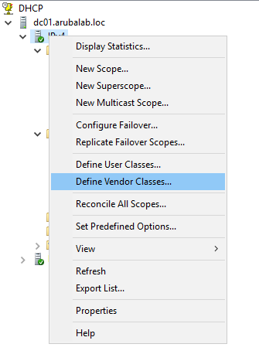

On the DHCP server, right click on the IPv4 item and select “Define Vendor Classes”.

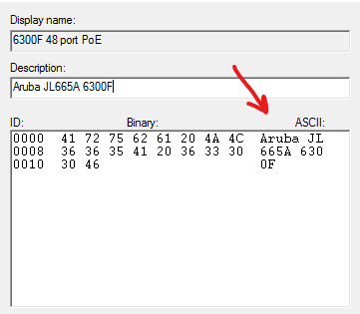

Click on “Add” and enter the information in the required fields. In the ASCII section of the form, you have to enter the Vendor Class Identifier (example shown below).

Click “Add” to add the Vendor Class.

Next is to define the predefined options for the Vendor Class. This is option 66 (for the TFTP server) and option 144 (for defining the configuration file).

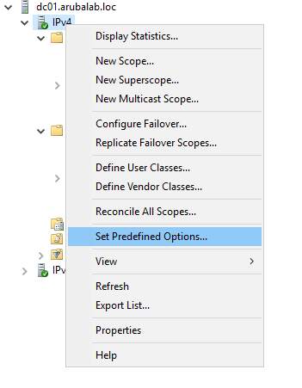

On the DHCP server, right click on the IPv4 item and select “Set Predefined Options”.

Option 66 is a default option that exists on the DHCP server, so this does not have to be configured, only option 144 has to be configured. When using DHCP address assigned ZTP, the default ZTP configuration file can be assigned to this option.

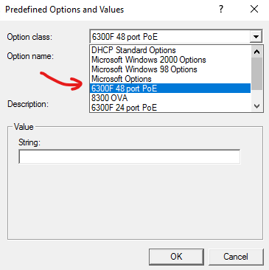

From the Option class select field, select the Vendor class, that you have created, and click “Add”.

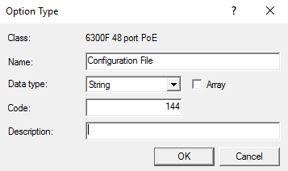

Add option code 144 (a string data type), provide a name/description, click “OK” and confirm the predefined options.

As said, there are two options for IP address assignment with ZTP, either through DHCP or static IP address assignment.

For DHCP assigned ZTP, the easiest way to configure the scope options is through a global policy. This policy is assigned to all the scopes.

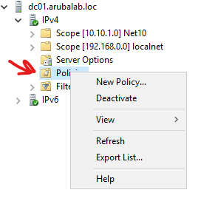

In the DHCP management tool, right click on the “Policies” item in the “IPv4 scope and select “New Policy”.

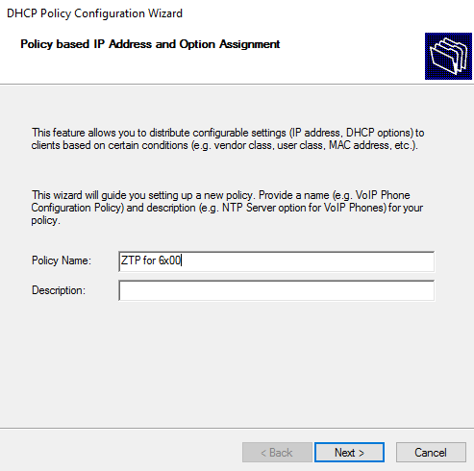

Provide a name (and optionally a description), and click “Next”.

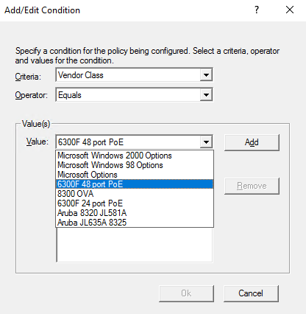

Add a condition, this is the Vendor Class Identifier condition. Click “Add”, and from the Vendor Class criterium, select the Vendor Class that you have created and click “Add”. Click “OK” to confirm.

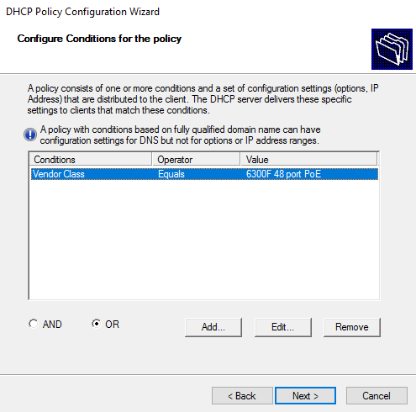

The condition is now in the list. Click “Next”.

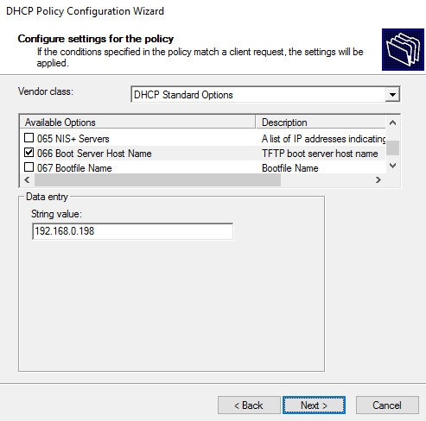

From the DHCP Standard Options, select option 66, and enter the IP address of the TFTP server. This is the IP address of the Compass app.

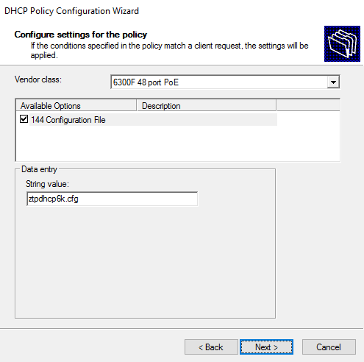From the Vendor class list, select the VCI that you have just created, select option 144, and enter the name of the configuration file. For the 6x00 series switches, the default configuration file name for ZTP through DHCP is **ztpdhcp6k.cfg**.

For the 83x0 series switches, the default configuration file name for ZTP through DHCP is **ztpdhcp8k.cfg**.

Click “Next”.

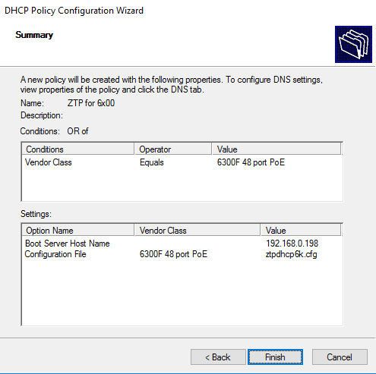

You now get an overview of the configured policy. Because this is a global policy, this will be active in all the DHCP scopes. Click “Finish” to add the policy.

You can repeat this process for other switches, first create the Vendor Class, then define the predefined options, and then configure a global policy.

If you are planning to use ZTP with static IP address assignment, you must configure a policy for each device. This is because the DHCP server needs to know which initial configuration file to push to the switch. You can either configure a global policy or define a policy in the scope where the switch resides. The process for defining a policy for a static IP address ZTP device is very similar to defining a policy for a DHCP ZTP device, the main differences are that you must set an additional condition, defining the MAC address of the switch, and assign a different configuration file.

Before configuration of the policy, you must obtain the MAC address of the switch that you want to zero touch provision. You can find the MAC address of the system (which is typically assigned to VLAN 1), on the box of the device and on the orange retractable tag on the switch. The management interface MAC address is the system MAC address + 1. For example, if the system MAC address (on the cardboard box) is 88:3A:30:01:01:**80**, this is the MAC address when you ZTP through one of the data ports. If you ZTP on the Management interface the MAC address will be 88:3a:30:01:01:**81**

This is important for the assignment of the configuration file on the DHCP server.

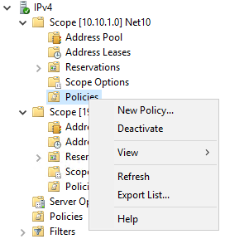As said, you can configure a global policy, or configure a policy in the DHCP scope. Right click on “Policies” and select “New Policy”.

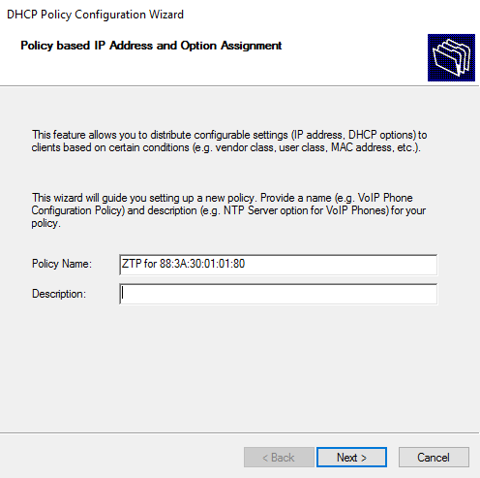

Provide a descriptive name for the policy and click “Next”.

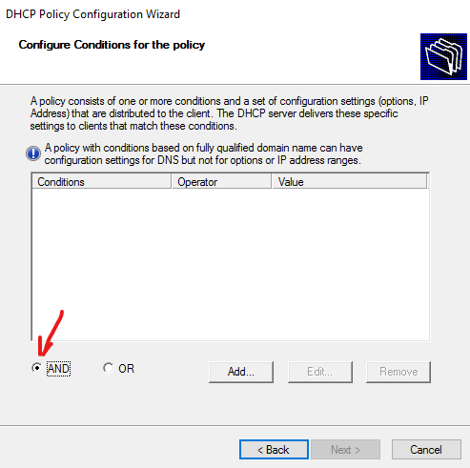

In the policy conditions, you are now checking on MAC address and Vendor Class, so you must select the “AND” operand.

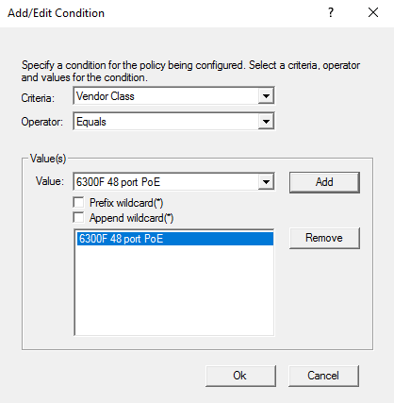

Add the conditions for the Vendor Class.

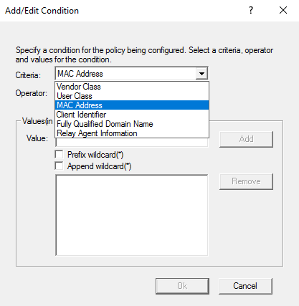And add another condition for the MAC address of the switch by selecting “MAC Address” from the criteria field

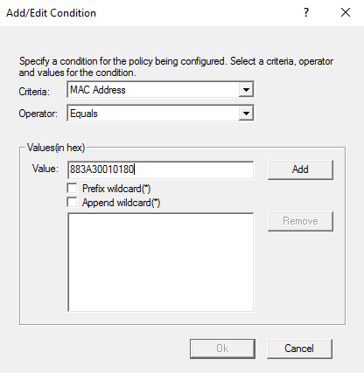

In the Value field, enter the MAC address without separators (only the hex value), and click “Add”.

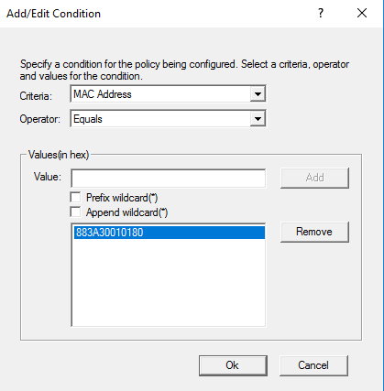

Click “Ok” to add the MAC address condition.

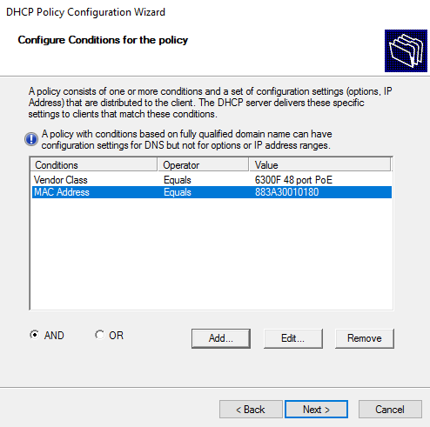

Click “Next”.

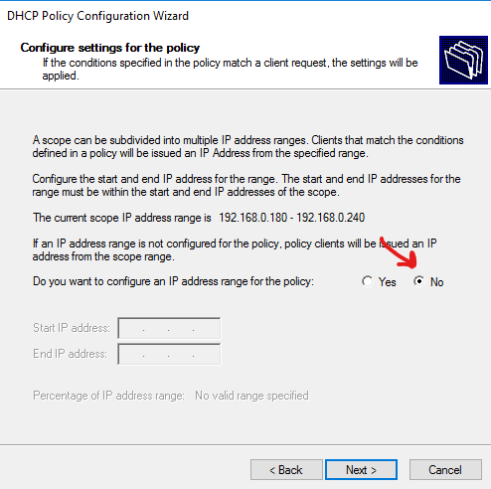

Skip the scope address options, by selecting “No”, and click “Next”.

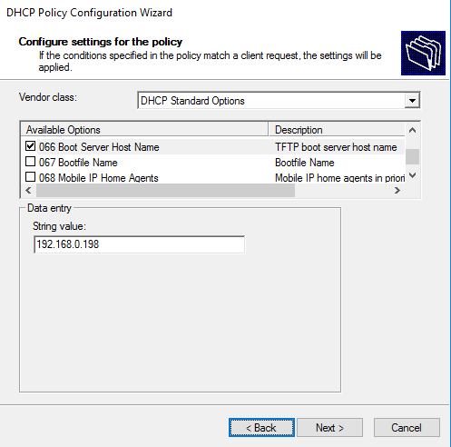

Next is to configure the scope options, 66 and 144. For option 66, select that option from the DHCP Standard Options Vendor class, and enter the IP address of the TFTP server.

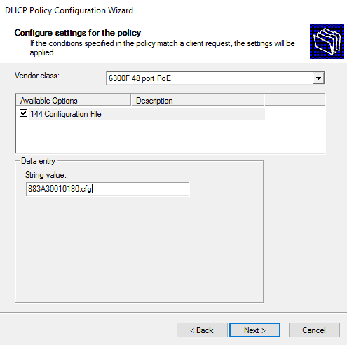

For option 144, instead of assigning the default ztpdhcp**.cfg, you have to provide the [macaddress].cfg as shown in the screenshot.

This is the configuration file that will be generated by the app, when ZTP is enabled for the selected device. This configuration file will contain the static IP address that will allow the app to communicate with the device.

Click “Next”.

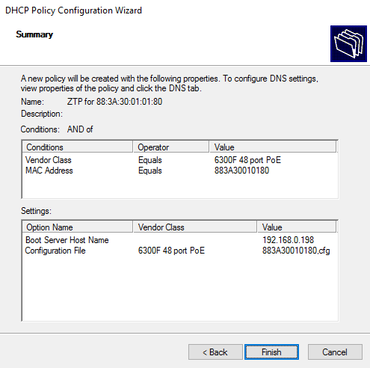

You will get an overview of the policy. Click “Finish”.

This concludes the configuration of the DHCP server.